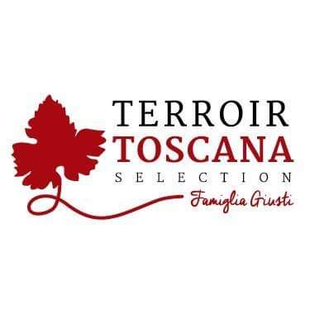Battuta of Giblets and Livers
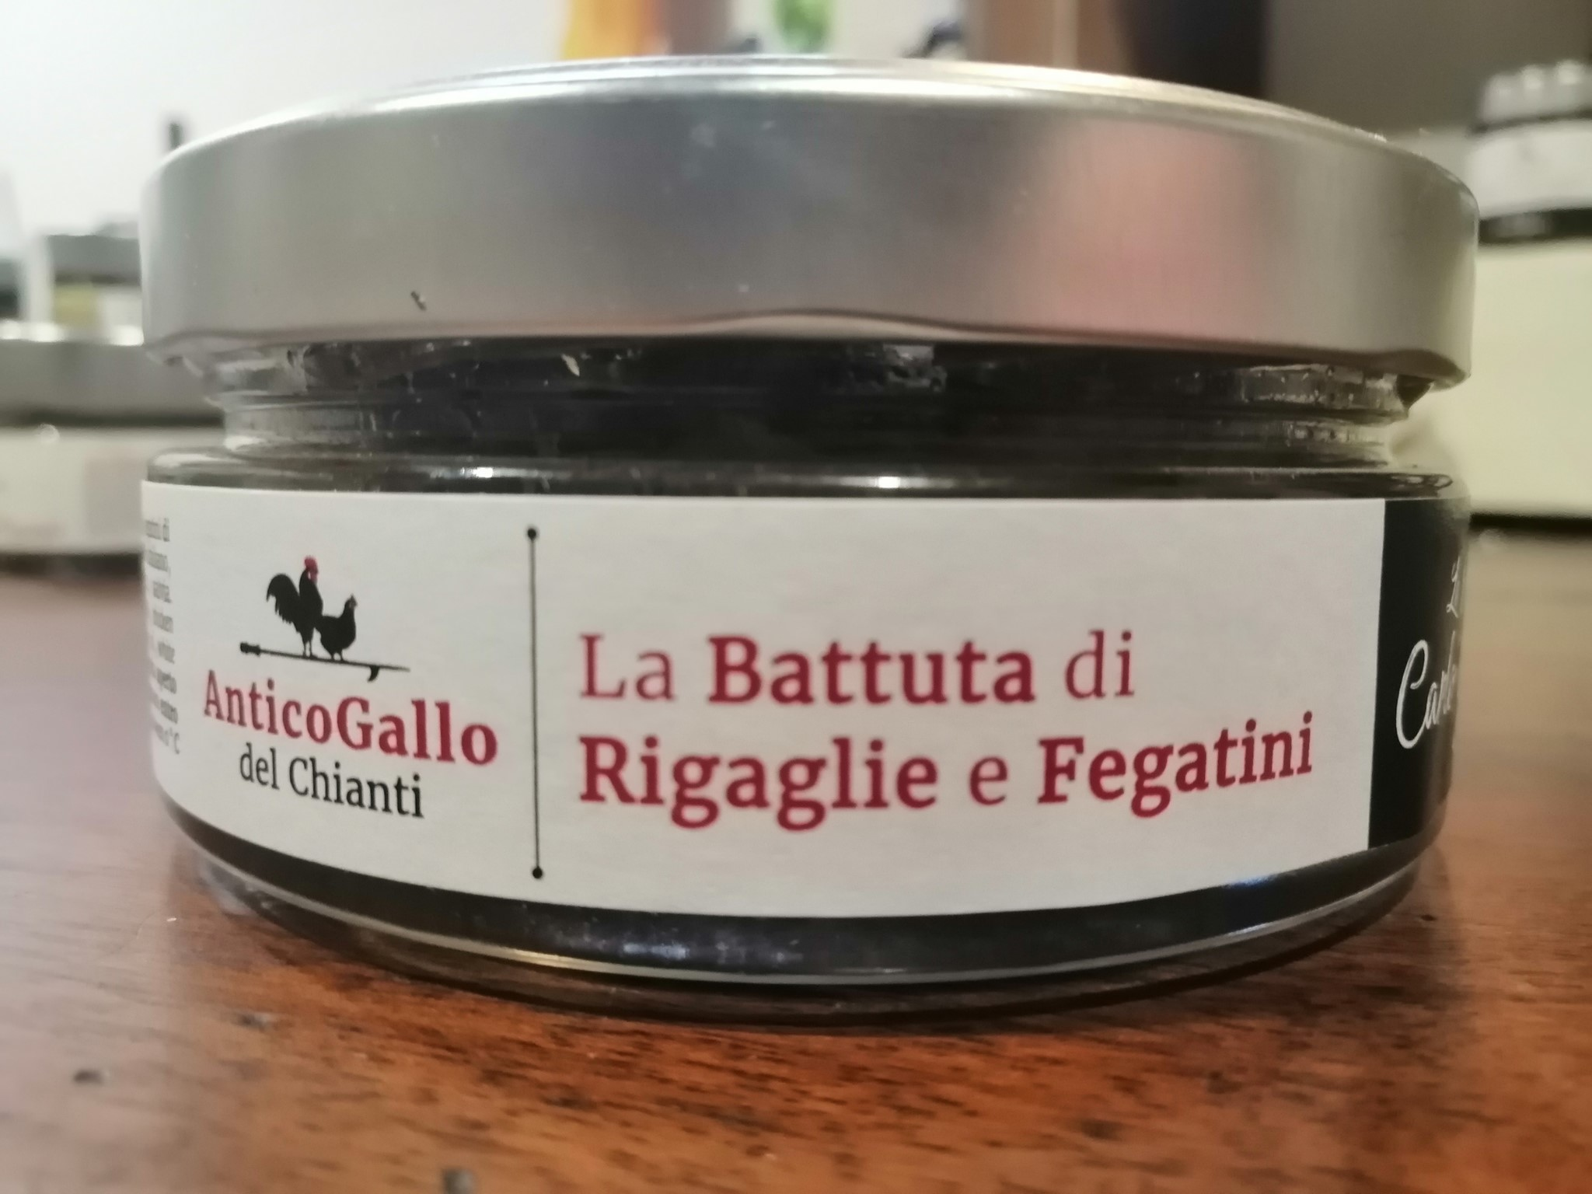From this noble and royal animal raised according to the techniques of ancient traditions, exclusively outdoors, with ORGANIC food, particular products are born, obtained from the skilful processing of its meat

USE: Excellent on lightly toasted brioche bread enriched with good butter. In combination with nice combinations of red fruits and black cherries. Flanked with medium-aged cheeses. Unusual and particular in combination with first courses, “bordatini”, fondues and polenta.
PRODUCT DESCRIPTION: It comes from a particular interpretation of the famous Tuscan pate crostino. The presence of coarser cuts of the raw material makes it much more enveloping on the palate. With a strong but never imposing taste Packaging: 180gr glass jar

PRODUCED AND PACKAGED FOR:
Soc. Agricola "La Vallata" Sas di Carlo Giusti - Lajatico (pisa) info@lavallatalajatico.it T. +39 0587640017
PRODUCED AND PACKAGED AT: Via Vinca 6, Castelfiorentino (Fi)
LABORATORY N °: IT 9628L CE
INGREDIENTS: Durelli and chicken hearts (58%), Chicken livers (16%), 100% Italian EVO oil, white onion, capers, anchovies, garlic, sage GLUTEN FREE product SHELF LIFE: expiration 24 months METHOD OF STORAGE: once opened, store in the fridge at a temperature between 0 ° and 4 ° C. and consume within 3/4 days
NUTRITIONAL VALUES
average for 100gr of product:

Energy: ………. 182 k / cal 759 k / j
Total fat …………………. 11.7 g
Of which saturated fatty acids .. 3.6 g
Carbohydrates ……………………. 1.5 g
Of which sugars .................. 0.7 g
Proteins ………………………… 17.7 g
Salt ……………………………… .0.84 g

