Mortadella of Angus Figs and Walnuts
Angus meat is considered among the best in the world for tenderness, juiciness and flavor.
The natural feeding of the animal also allows to obtain a nutritionally excellent quality of the meats that are rich in: iron, Omega3 and "good" fats.
The bovine breed, of ancient Scottish origins, now widespread all over the world, boasts of being one of the most sought after and appreciated meats ever.
The territory of the Tuscan hills with its environmental uniqueness and its particular terroir gives us a singular and unique expression of these highly prized meats.
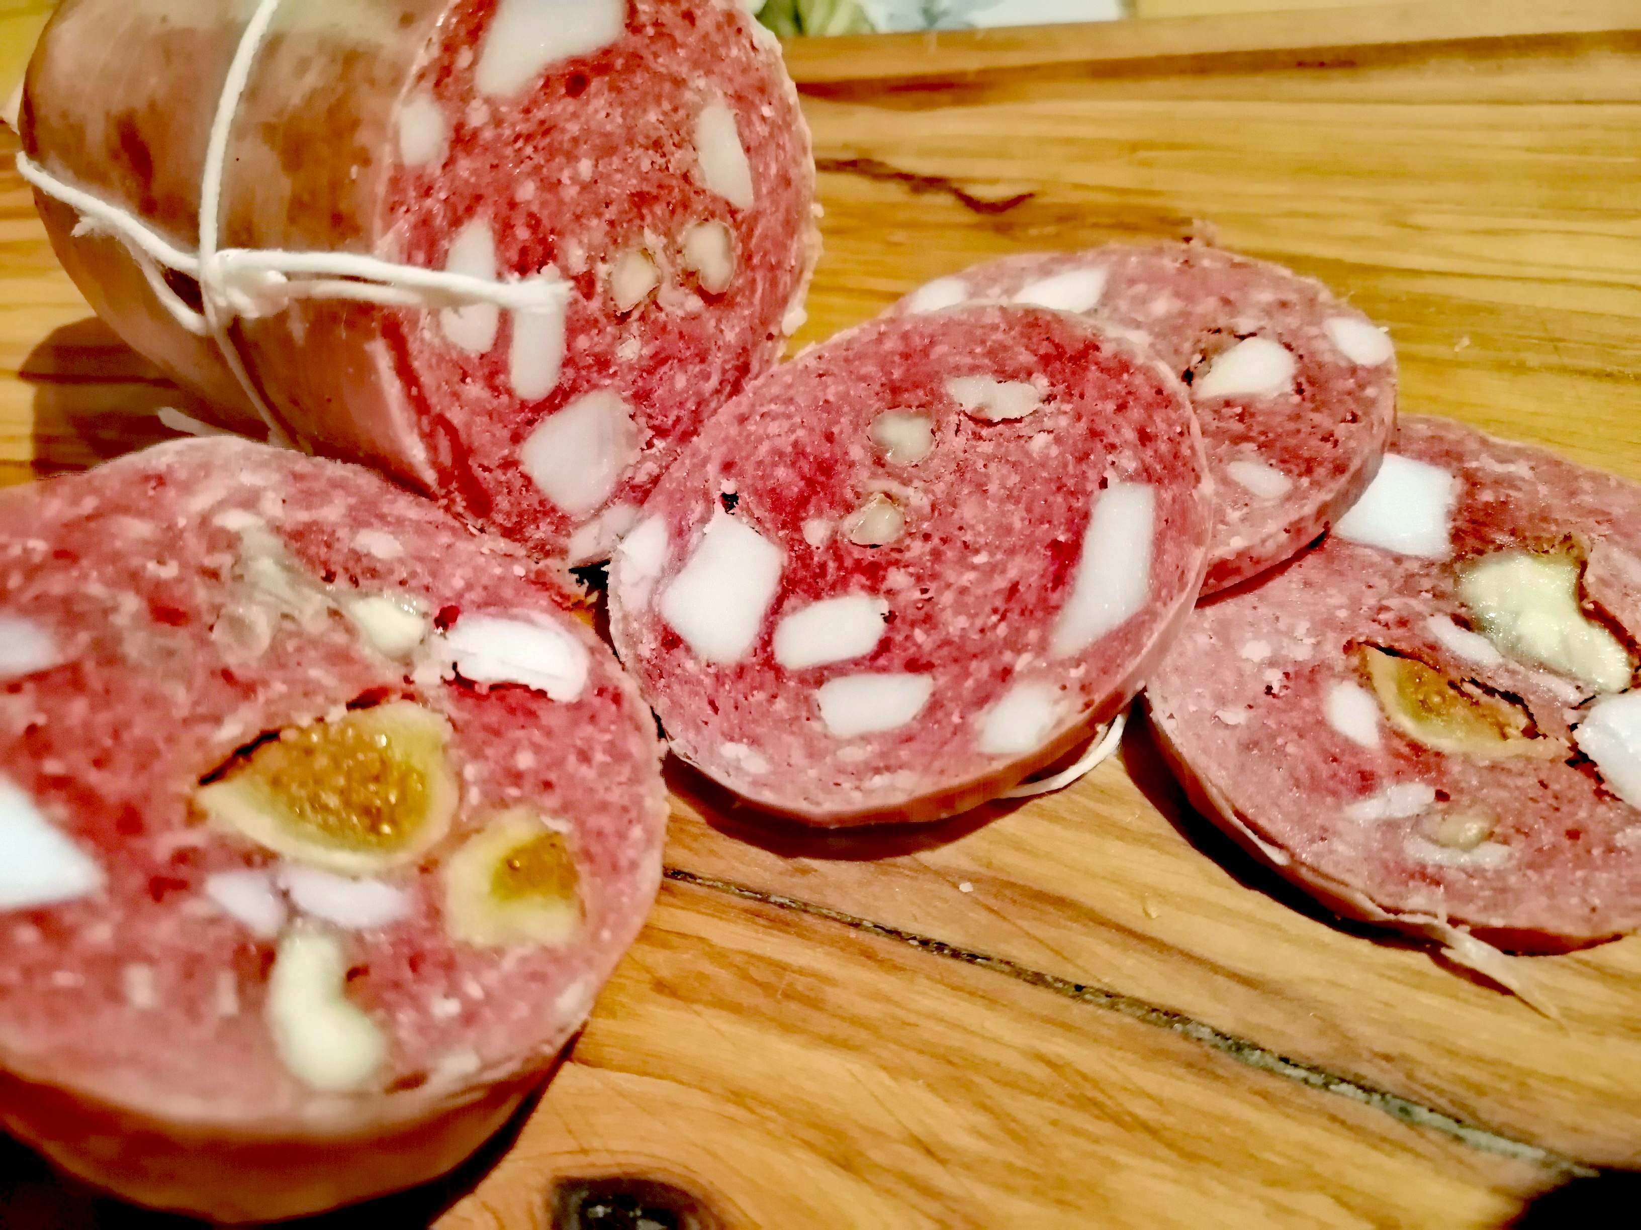

USE:
Excellent product to be served as an aperitif, in particular cutting boards, lightly au gratin on the plate or even made a filling for tortelli and ravioli, but not to be disdained but in abundant quantities inside a nice hot focaccia and, why not, on a particular Gourmet pizza with goat cheese.
PRODUCT DESCRIPTION:
This mortadella is born from the noble art of pork butchery. Artisan product obtained according to the classic tradition enriched with the unusual and fragrant notes of figs and walnuts, for a truly captivating taste.

Packaging: vacuum-packed product sold by weight

NUTRITIONAL VALUES
average for 100gr of product:

Power:………. k / cal k / j
Total fat ………………… .g
Of which saturated fatty acids .. g
Carbohydrates ………………… g
Of which sugars ............... g
Proteins ………………………… g
Salt ……………………………… .g
PRODUCED AND PACKAGED FOR:
Soc. Agricola "La Vallata" Sas di Carlo Giusti - Lajatico (pisa) info@lavallatalajatico.it
T. +39 0587640017
PRODUCED AND PACKAGED AT:
LABORATORY N °:
INGREDIENTS: Angus thigh pulp BOV AD., Salt, aromatic plants, sucrose, pepper, garlic, dextrose, figs, nuts SHELF LIFE: expiration 60 days METHOD OF STORAGE: store at a temperature between 0 ° and 4 ° C. Do not puncture the package. Open the vacuum pack and re-oxygenate before consumption

