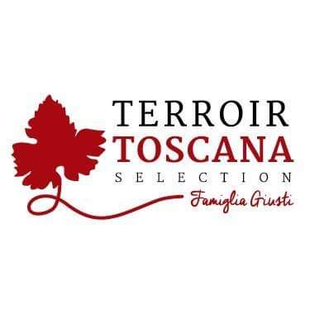Mortadella of Suino Brado
From this particular pig obtained from crosses between the noble Cinta Senese and the wild boar, one of the most extraordinary and elegant pork meat is accidentally born.
Raised in the wild in total freedom, it feeds on the products of the forest and undergrowth, enriched by NATURAL and ORGANIC food that "La Vallata" itself produces.
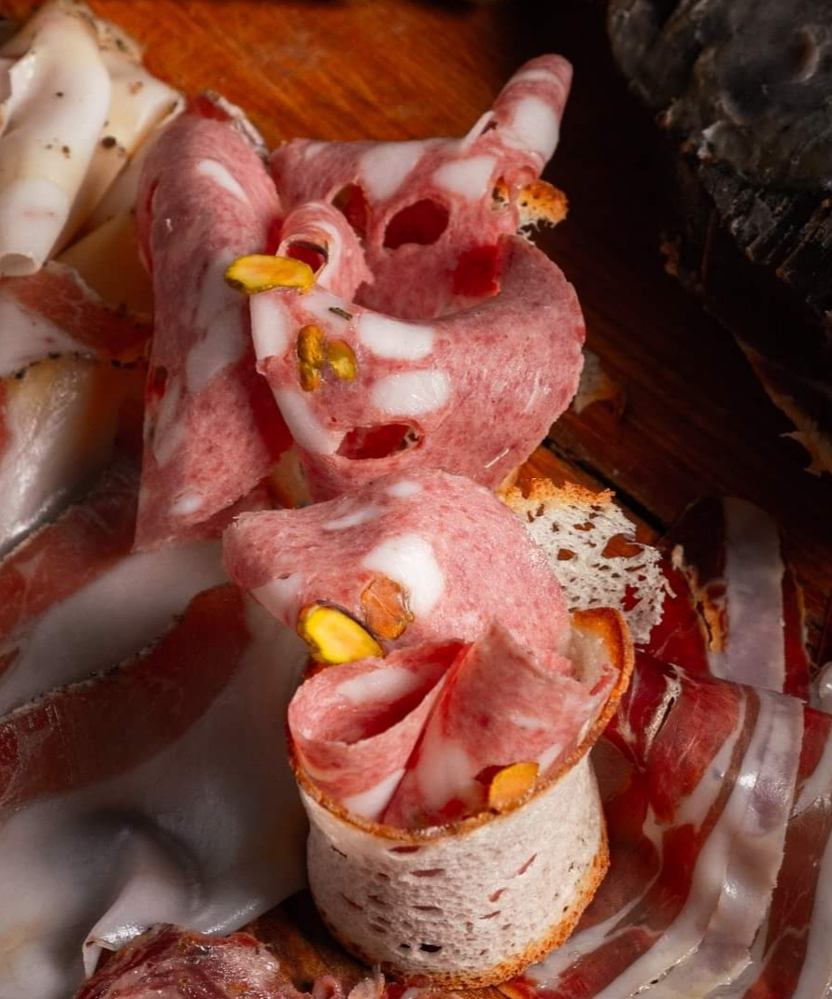

PRODUCT DESCRIPTION:
This mortadella is born from the noble art of norcina. Artisan product obtained according to the classic tradition enriched with pistachios

Packaging: vacuum-packed product sold by weight

USE:
Excellent product to be served as an aperitif, in particular cutting boards, lightly au gratin on the plate or even made a filling for tortelli and ravioli, but not to be disdained but in abundant quantities inside a nice hot focaccia and, why not, on a particular Gourmet pizza with goat cheese.
PRODUCED AND PACKAGED FOR:
Soc. Agricola "La Vallata" Sas di Carlo Giusti - Lajatico (pisa) info@lavallatalajatico.it
T. +39 0587640017
PRODUCED AND PACKAGED AT:
LABORATORY N °:
INGREDIENTS: Shoulder of wild pork (80%), pistachios, natural flavors, E250 SHELF LIFE: expiration 60 days METHOD OF STORAGE: store at a temperature between 0 ° and 4 ° C. Do not puncture the package. Open the vacuum pack and re-oxygenate before consumption
NUTRITIONAL VALUES
average for 100gr of product:

Energy: ............ 239 k / cal 997 k / j
Total fat …………………. 15.0 g
Of which saturated fatty acids .. 4.9 g
Carbohydrates ………………… <0.5 g
Of which sugars ............... <0.5 g
Proteins ………………………… 26 g
Salt ………………………………. 3.0 g

