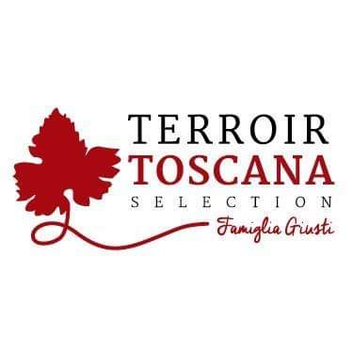Rooster Cigar
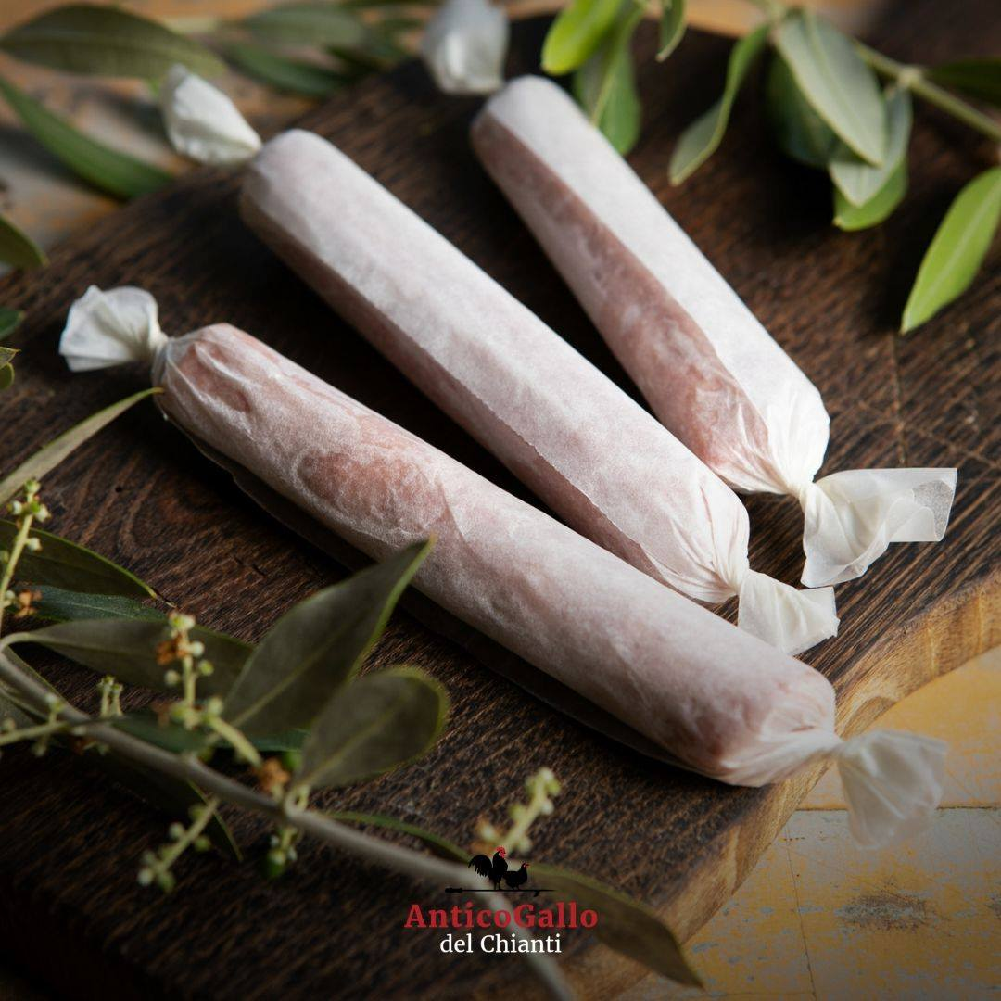From this noble and royal animal raised according to the techniques of ancient traditions exclusively outdoors with ORGANIC food, particular products are born, obtained from the skilful processing of its meat.

PRODUCT DESCRIPTION:
"Artisan Wurstel" created by the noble art of pork butchery, one of my follies with a unique and genuine flavor

Packaging: vacuum-packed product sold by weight

USE: Delicious and genuine to be savored as it is, simply grilled or steamed. It is widely used in the preparation of particular mixtures, mousses and foams. It reaches the maximum of its exaltation in the interpretation of bakery products and Gourmet Pizzas
INGREDIENTS: Tuscan chicken meat (95%), salt, natural flavors, E250 SHELF LIFE: expiration 45 days METHOD OF STORAGE: store at a temperature between 0 ° and 4 ° C. Do not puncture the package. Open the vacuum pack and re-oxygenate before consumption
PRODUCED AND PACKAGED FOR:
Soc. Agricola "La Vallata" Sas di Carlo Giusti - Lajatico (pisa) info@lavallatalajatico.it
T. +39 0587640017
PRODUCED AND PACKAGED AT:
LABORATORY N °:
NUTRITIONAL VALUES
average for 100gr of product:

Energy: ………. 232 k / cal 969 k / j
Total fat …………………. 14.0 g
Of which saturated fatty acids .. 4.4 g
Carbohydrates ………………… <0.5 g
Of which sugars ............... <0.5 g
Proteins ………………………… 26 g
Salt ……………………………… .2.6 g

