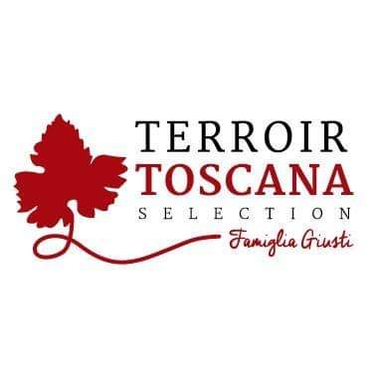Rooster Mortadella with almonds and black pepper
From this noble and royal animal raised according to the techniques of ancient traditions exclusively outdoors with ORGANIC food, particular products are born, obtained from the skilful processing of its meat.

PRODUCT DESCRIPTION:
This mortadella is born from the noble art of norcina. Artisan product obtained according to the classic tradition enriched with quality almonds and black pepper in grains.

Packaging: vacuum-packed product sold by weight

USE:
Excellent product to be served as an aperitif, in particular cutting boards, lightly au gratin on the plate or even made a filling for tortelli and ravioli, but not to be disdained but in abundant quantities inside a nice hot focaccia and, why not, on a particular Gourmet pizza with goat cheese.
PRODUCED AND PACKAGED FOR:
Soc. Agricola "La Vallata" Sas di Carlo Giusti - Lajatico (pisa) info@lavallatalajatico.it
T. +39 0587640017
PRODUCED AND PACKAGED AT:
LABORATORY N °:
NUTRITIONAL VALUES
average for 100gr of product:

Energy: ………. 232 k / cal 969 k / j
Total fat …………………. 14.0 g
Of which saturated fatty acids .. 4.4 g
Carbohydrates ………………… <0.5 g
Of which sugars ............... <0.5 g
Proteins ………………………… 26 g
Salt ……………………………… .2.6 g
INGREDIENTS: Tuscan chicken meat (85%), almonds (2%), pork lard, salt, black pepper (0.5%), natural flavors, E250 SHELF LIFE: expiration 60 days METHOD OF STORAGE: store at a temperature between 0 ° and 4 ° C. Do not puncture the package. Open the vacuum pack and re-oxygenate before consumption

