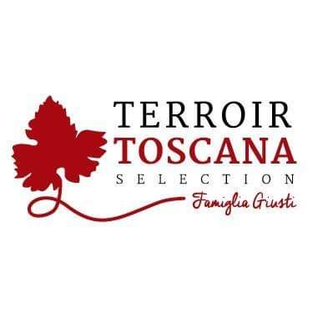Rooster Sauce with Truffles
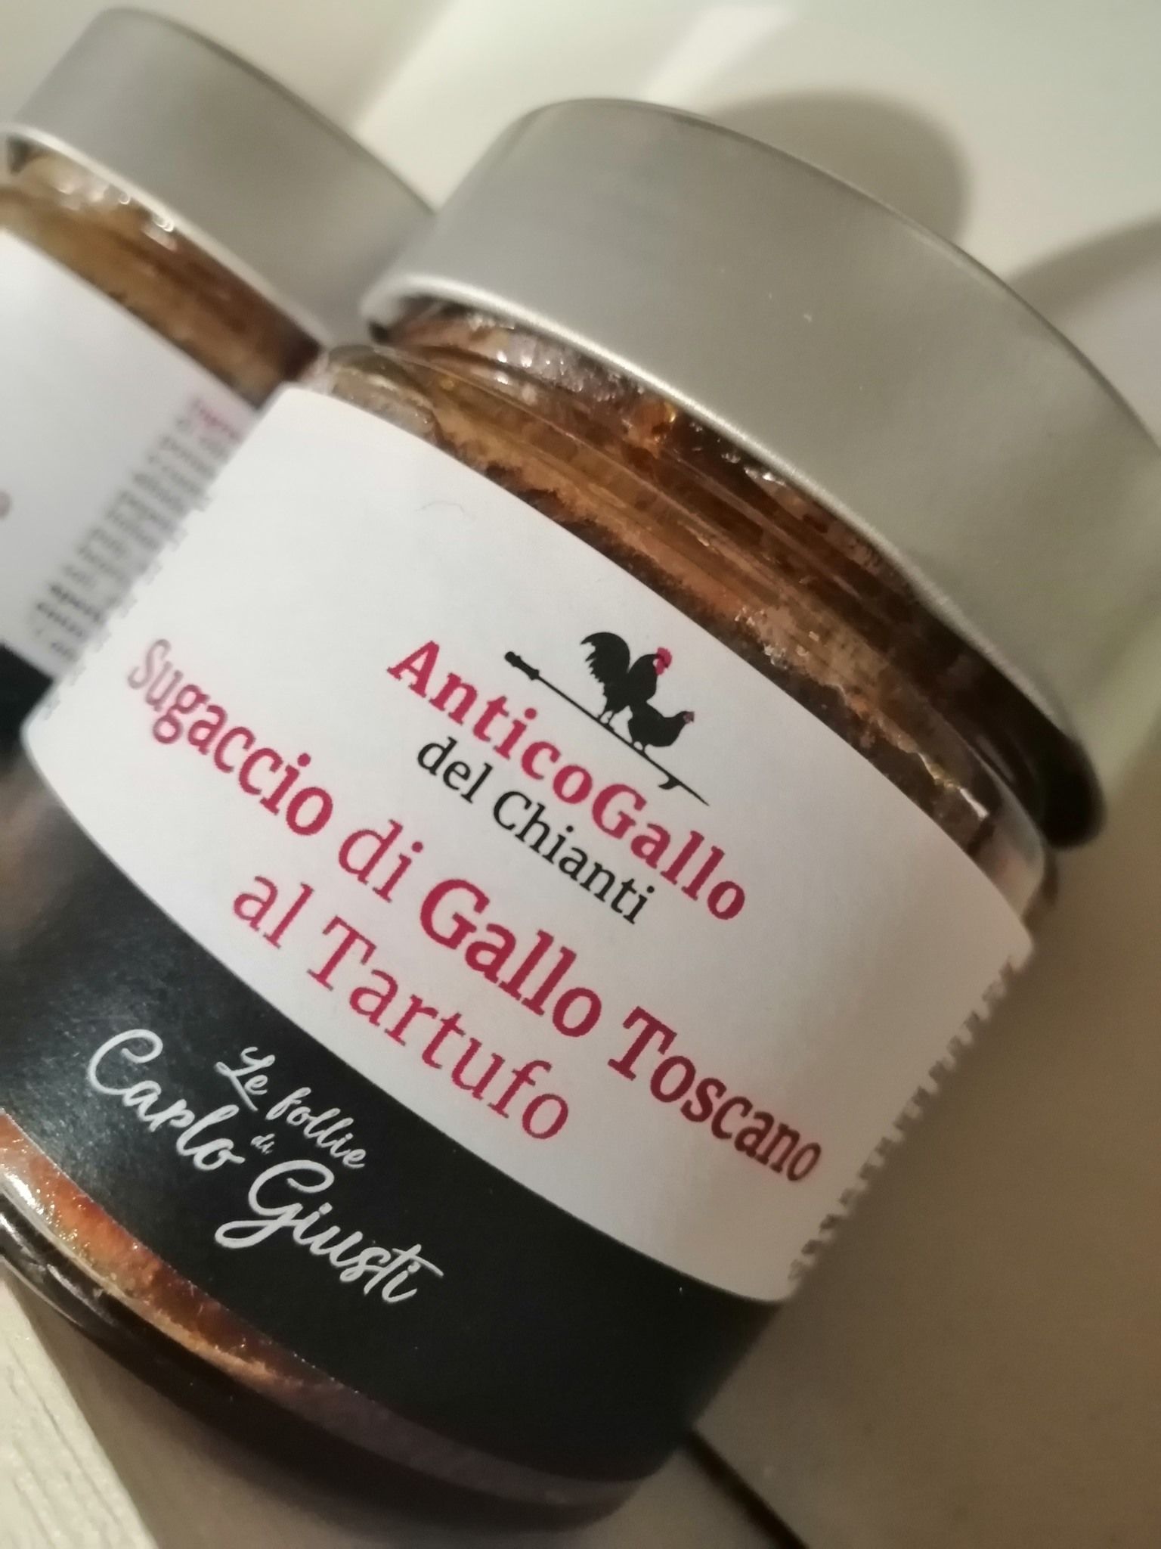From this noble and royal animal raised according to the techniques of ancient traditions exclusively outdoors with ORGANIC food, particular products are born, obtained from the skilful processing of its meat.

USE: An exceptional and extremely versatile product that accompanies croutons and fine first courses. Excellent on hot croutons, delicious canapés and voulevant. It is appreciated in combination with particular cheeses. It finds its culmination as a condiment for noble artisan pastas and polenta characteristics.
The presence of strictly natural truffles makes it the prince of important evenings.
PRODUCT DESCRIPTION:
From the noble meat of this Tuscan Rooster, combined with the skilful culinary gift of "Mamma Vania", after careful craftsmanship, this line of products is born which aims to evoke tradition in all respects.
Packaging: glass jar 180gr

PRODUCED AND PACKAGED FOR:
Soc. Agricola "La Vallata" Sas di Carlo Giusti - Lajatico (pisa) info@lavallatalajatico.it
T. +39 0587640017
PRODUCED AND PACKAGED AT: Via Vinca 6 Castelfiorentino (Fi)
LABORATORY N °: IT 9628L CE
INGREDIENTS: Tuscan chicken meat (50%), 100% Italian EVO oil, tomato paste, organic tomato pulp, celery, white wine, chicken durelli, chicken livers and hearts, ground Italian bianchetto truffle-Tuber Albidum Pico (2, 5%), salt, parsley, garlic, sage, pepper, chilli. GLUTEN FREE product SHELF LIFE: expiration 24 months METHOD OF STORAGE: once opened, store in the fridge between 0 ° and 4 ° C. and consume within 3/4 days
NUTRITIONAL VALUES
average for 100gr of product:

Energy: ............ 134 k / cal 553 k / j
Total fat …………………. 11.2 g
Of which saturated fatty acids .. 2.7 g
Carbohydrates ………………… <0.1 g
Of which sugars ............... <0.1 g
Proteins ………………………… 8,2g
Salt …………………………… 1.12 g

