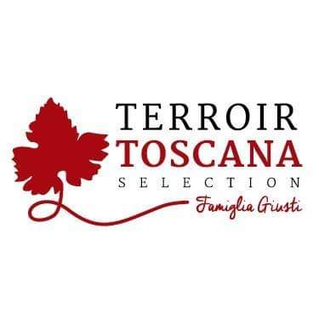The Pigeon Bottarga
From a long and careful selection of these wonderful animals, meats with a particular protein content are made.

USE:
Its use leaves interpretation to the most varied culinary fantasies as a flavoring of consommé, fondues, special first courses, excellent in risottos but also elegant combinations with main courses of both meat and fish. A product still to be discovered and therefore to be interpreted according to the imagination that each of you has in the kitchen
PRODUCT DESCRIPTION: It comes from careful hand processing of extremely seasoned Pigeon Ham. In fact, by grating the cured Pigeon Ham, particular curls are obtained that are very similar to the bottarga from which this unusual product with a pungent odor, very fine and elegant to the taste, a persistent but pleasant experience of the palate takes its fancy name
Packaging: 30gr glass jar
PRODUCED AND PACKAGED FOR:
Soc. Agricola "La Vallata" Sas di Carlo Giusti - Lajatico (pisa) info@lavallatalajatico.it T. +39 0587640017
PRODUCED AND PACKAGED AT: Via Lavoria N.21, 56040 Crespina- Lorenzana (Pisa)
LABORATORY N °: IT Z636H CE
INGREDIENTS: Pigeon meat, salt, pepper, aromatic herbs. GLUTEN FREE product SHELF LIFE: expires 6 months
METHOD OF STORAGE: once opened, store in the fridge between 0 ° and 4 ° C.
NUTRITIONAL VALUES
average for 100gr of product:

Energy: ………. 299 k / cal 955 k / j
Total fat …………………. 15.0 g
Of which saturated fatty acids .. 4.0 g
Carbohydrates ………………… <0.5 g
Of which sugars ............... <0.5 g
Proteins ………………………… 22 g
Salt ……………………………… .2.8 g

