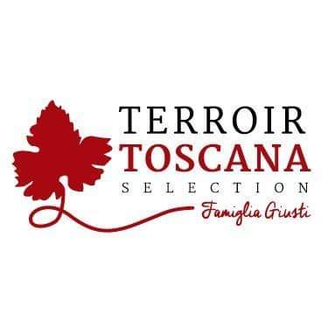The Pigeon Ham
From a long and careful selection of these wonderful animals, meats with a particular protein content are made.
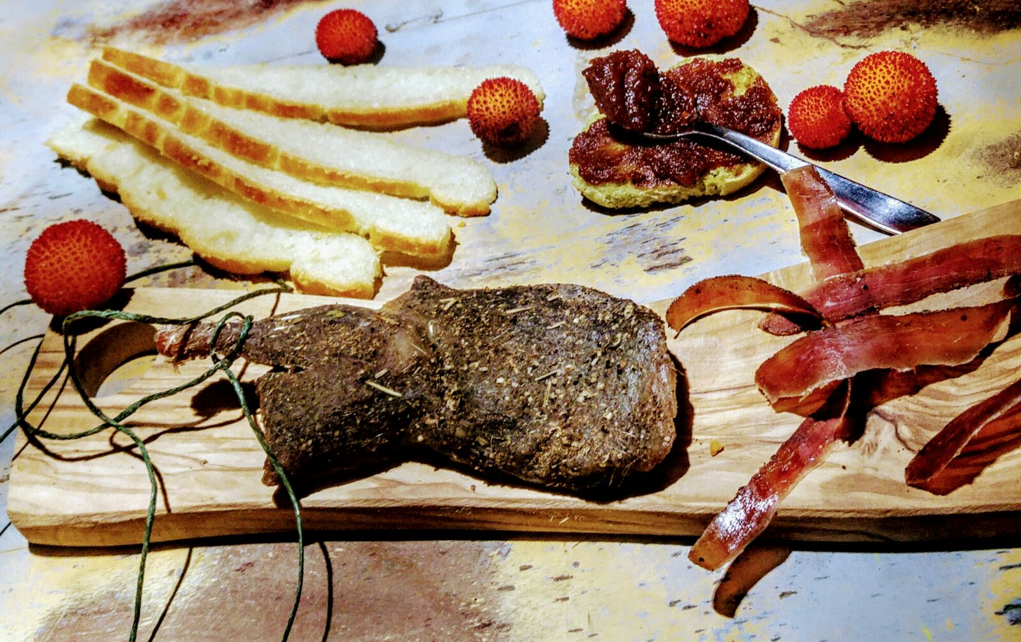

PRODUCT DESCRIPTION:
From a careful and meticulous processing of pork butchery art and skilled hands after a few months of curing, in particular marble tubs, wrapped in a blend of local aromatic plants, this wonderful and unique product is born.

Packaging: vacuum-packed product sold by weight

USE: Excellent as it is. To be eaten finely cut in "Fingertips", such as "Carpaccino", in combination with fresh vegetables, a real salami enriches cutting boards of particular value. Supporting crostini and salads, a true explosion of taste with soft cheeses of not marked flavor. Excellent in combination with mustards with a delicate but not excessive presence of a sugary note: Product of great versatility suitable for any use that your culinary imagination gives you.
PRODUCED AND PACKAGED FOR:
Soc. Agricola "La Vallata" Sas di Carlo Giusti - Lajatico (pisa)
info@lavallatalajatico.it
T. +39 0587640017
PRODUCED AND PACKAGED AT:
Via Lavoria N.21, 56040
Crespina- Lorenzana (Pisa)
LABORATORY N °: IT Z636H CE
_{INGREDIENTS:}
_{Pigeon meat, salt, pepper,}
_{Herbs.}
_{GLUTEN FREE product}
_{SHELF LIFE: expires 6 months}
_{METHOD OF STORAGE:}
store at a temperature between 0 ° and 4 ° C. Do not puncture the package.
Open the vacuum pack and re-oxygenate before consumption
NUTRITIONAL VALUES
average for 100gr of product:

Energy: ………. 299 k / cal 955 k / j
Total fat …………………. 15.0 g
Of which saturated fatty acids .. 4.0 g
Carbohydrates ………………… <0.5 g
Of which sugars ............... <0.5 g
Proteins ………………………… 22 g
Salt ……………………………… .2.8 g

